## INTERNSHIP-1 Report

**ON**

**CBIT ONLINE CANTEEN PORTAL**

**B.E.(IT) III-Sem**

BY

**PALLERLA JAYADIR (160122737191)**

**CH. SHIVA KRISHNA (160122737173)**

**M. YAMINI SARASWATHI (160122737149)**

**G. MANIDEEP (160122737178)**

UNDER THE GUIDANCE OF

**Mrs. KH Vijaya Kumari**

Assistant Professor,

IT Department, CBIT.



**DEPARTMENT OF INFORMATION TECHNOLOGY**

**CHAITANYA BHARATHI INSTITUTE OF TECHNOLOGY (A)**

**(Affiliated to Osmania University; Accredited by NBA and NAAC, ISO 9001:2015 Certified Institution), GANDIPET, HYDERABAD – 500 075**

**Website:** [**www.cbit.ac.in**](http://www.cbit.ac.in)

**2023-2024**



**CERTIFICATE**

This isto certify that the project work entitled “CBIT Online Canteen Portal” submitted to CHAITANYA BHARATHI INSTITUTE OF TECHNOLOGY, in partial fulfillment of the requirements for the completion of Internship-1 in III Sem of B.E. In Information Technology during the Academic Year 2023-24, is a record of original work done by, PALLERLA JAYADIR (160122737191), CH. SHIVA KRISHNA (160122737173), M. YAMINI SARASWATHI (160122737149), G. MANIDEEP (160122737178) during the period of study in the Department of IT, CBIT, Hyderabad, under our guidance.

**Project Guide**  **Head of the Department**

**Mrs KH Vijaya Kumari Dr. Rajanikanth Aluvalu**

Assistant Professor, Dept. of IT, Professor, Dept. of IT,

CBIT, Hyderabad. CBIT, Hyderabad.

**DECLARATION**

We declare that the project report entitled **“CBIT Online Canteen Portal”** is being submitted by us in the Department of Information Technology, Chaitanya Bharathi Institute of Technology (A), Osmania University.

This is record of bonafide work carried out by us under the guidance and supervision of Mrs. KH Vijaya Kumari**,** Assistant Professor, Dept. of IT, C.B.I.T.

No part of the work is copied from books/journals/internet and wherever the portion is taken, the same has been duly referred in the text. The reported are based on the project work done entirely by us and not copied from any other source.

**P. JAYADIR - 160122737191**

**M.YAMINI SARASWATHI-160122737149**

**CH. SHIVA KRISHNA-160122737173**

**G.MANIDEEP-160122737178**

## ACKNOWLEDGEMENTS

We would like to express our heartfelt gratitude to Mrs. KH Vijaya Kumari, our project guide, for her invaluable guidance and constant support, along with her capable instruction and persistent encouragement.

We would like to express our heartfelt gratitude to <<External Name>>, our external mentor, for his/ her invaluable guidance and constant support, along with her capable instruction and persistent encouragement.

We are grateful to our Head of Department, Dr. Rajanikanth Aluvalu, for his steady support and for the provision of every resource required for the completion of this project.

We would like to take this opportunity to thank our Principal, Dr. C Venkata Narasimhulu, as well as the Management of the Institute, for having designed an excellent learning atmosphere.

Our thanks are due to all members of the staff and our lab assistants for providing us with the help required to carry out the groundwork of this project.

**ABSTRACT**

In response to the challenges faced by college students, our team has created an Online Canteen Portal using the MERN stack. This user-friendly platform allows students to easily order food from their mobile devices, eliminating the need to wait in queues. Considering the impact of COVID-19, the portal integrates contactless payment methods, ensuring a safer and more convenient transaction process.

The portal offers a straightforward interface for browsing the menu, customizing orders, and receiving real-time updates on order status. Built on Node.js and Express.js for the backend, with MongoDB as the database, and React.js for the frontend, the system provides a responsive and dynamic user experience. The integration of modern web technologies facilitates efficient data storage and real-time updates.

By reducing wait times and introducing contactless payments, the Online Canteen Portal not only addresses the immediate concerns of students but also aligns with safety measures during the pandemic. This report provides an overview of the project's objectives, technologies used, system architecture, and user functionalities, highlighting its significance in adapting to the evolving needs of college students in the post-pandemic era.

**TABLE OF CONTENTS**

|  |  |  |
| --- | --- | --- |
|  |  | Page. No |
|  | Abstract | v |
|  | List of Figures | vii |
| 1. | INTRODUCTION |  |
|  | 1.1 Overview | viii |
|  | 1.2 Applications | viii |
|  | 1.3 Motivation | viii |
|  | 1.4 Problem Statement | ix |
|  | 1.5 Objectives | ix |
| 2. | EXISTING SYSTEM |  |
|  | 2.1 Literature survey | ix |
| 3. | SYSTEM REQUIREMENT SPECIFICATION |  |
|  | 3.1 Functional Requirements | x |
|  | 3.2 Non-Functional Requirements | x |
|  | 3.3 Software Requirements | x |
|  | 3.4 Hardware Requirements | xi |
| 4. | PROPOSED METHODOLOGY |  |
|  | 4.1 System Architecture/ System Design/ Algorithms | xi |
| 5. | IMPLEMENTATION & RESULTS | xiii |
| 6. | CONCLUSION AND FUTURE SCOPE |  |
|  | 6.1 Conclusion | xviii |
|  | 6.2 Limitations | xviii |
|  | 6.3 Future Scope | xviii |
|  | BIBLIOGRAPHY | xix |

**LIST OF FIGURES**

|  |  |
| --- | --- |
| **Figure 1** | SIGN-UP PAGE |
| **Figure 2** | LOGIN PAGE |
| **Figure 3** | HOME PAGE WHEN LOGGED OUT |
| **Figure 4** | HOME PAGE |
| **Figure 5** | CART |
| **Figure 6** | CHECKOUT |
| **Figure 7** | NOTIFICATION AFTER PAYMENT |
| **Figure 8** | EMPTY CHECKOUT |
| **Figure 9** | PREVIOUS ORDERS |
| **Figure 10** | DATABASE |

**1. INTRODUCTION**

The Canteen Portal marks a progressive shift in how students engage with on-campus dining. Imagine saying goodbye to long queues and embracing an ordering system right from your phone. It's more than just a convenience upgrade; it's a streamlined solution for today's college lifestyle. By providing a user-friendly mobile interface, the Canteen Portal simplifies the ordering process, eliminating the need for physical queues and boosting overall efficiency.

This innovative platform understands the modern student's need for simplicity. With easy menu navigation, order customization, and real-time tracking, it's a hassle-free dining experience. The technology behind it, utilizing Node.js, Express.js, MongoDB, and React.js, ensures a smooth and responsive user journey. The Canteen Portal is more than an upgrade; it's a tailored response to the evolving preferences of college students, making dining on campus more straightforward and user-centric.

* 1. **OVERVIEW**

The Canteen Portal is a modern solution designed to redefine the dining experience for college students. This project introduces a user-friendly platform, leveraging contemporary technologies to enhance the efficiency and convenience of on-campus food services.

* 1. **APPLICATIONS**
* Streamlines menu browsing and order placement.
* Facilitates secure and hygienic online payment methods.
* Allows users to explore a detailed and visually appealing menu.
* Enables access to order history and easy reordering of favorite items.
* Assists administrators in efficient order and inventory management.
* Minimizes physical queues and crowds in the canteen.
* Implements promotional offers, discounts, and loyalty programs.
* Enables users to provide feedback and ratings for orders.
* Adapts to changing circumstances and scales to accommodate growth.
  1. **MOTIVATION**

The online canteen portal is motivated by a simple goal: to make ordering food on campus easier and more convenient. It aims to cut down wait times, adapt to modern student preferences, and ensure a secure and streamlined transaction process with contactless payments. By embracing technology, the portal seeks to enhance the overall user experience, offering insights for better decision-making and creating a space for engaging promotions. In essence, the motivation is straightforward- to simplify and improve the way students order and enjoy their food.

* 1. **PROBLEM STATEMENT**

Since most of the colleges have started to reopen and people are returning to their normal lives, we have to ensure that all of us follow safety protocols and prevent public overcrowding. This is an application where students can order food from the website and can pick it up from the canteen with all the precautions necessary.

* 1. **OBJECTIVES**

The primary objectives of this project revolve around enhancing the campus food experience for students returning to college. Our focus is on creating an efficient and secure online ordering system, implementing contactless transactions, and ensuring a safe pickup model that aligns with health protocols. We aim to cultivate a safety-conscious culture by educating users and staff, while also providing adaptability for changing circumstances. Robust data security measures and a user-friendly feedback mechanism contribute to an overall goal of delivering a seamless, convenient, and safe food ordering experience on campus.

**2. EXISTING SYSTEM**

**2.1 LITERATURE STUDY**

In today's college canteens, dealing with crowded spaces is a common challenge. This often leads to long queues, making it difficult for students to both make payments and receive their order tokens efficiently. Crowds can result in payment delays, causing inconvenience and frustration. Additionally, the process of taking tokens for food orders becomes challenging due to the sheer volume of students.

To address these issues, technology like online ordering and mobile apps has become increasingly popular. These tools allow students to order in advance and pay online, reducing wait times and payment-related problems. Furthermore, an efficient token system, possibly integrated with the online ordering process, can help streamline the pickup process, making it smoother for both students and canteen staff.

Understanding when canteens are most crowded and what students prefer to eat is essential. This is where data analysis comes in. By looking at this information, canteen staff can make smarter decisions to improve the overall experience, addressing not only payment issues but also streamlining the process of taking tokens. The focus is on using simple, tech-based solutions to make the dining experience safer, more efficient, and enjoyable for students amidst crowded canteen scenarios.

**3. SYSTEM REQUIREMENT SPECIFICATION**

**3.1 FUNCTIONAL REQUIREMENT**

* User Registration: Users, mainly students, can register with unique credentials.
* Menu Browsing: Display a comprehensive menu with food items, categories, and prices for user exploration.
* Order Placement: Enable secure selection, customization, and placement of food orders.
* Secure Payment Processing: Facilitate secure online payment options for completed orders.
* Contactless Token System: Implement a contactless token system for order identification and pickup.

**3.2 NON-FUNCTIONAL REQUIREMENTS**

* Security: Ensure robust data security for user information and transaction details.
* Usability: Create a seamless and user-friendly interface with intuitive navigation.
* Scalability: Design the system to efficiently scale with potential user and feature increases.
* Reliability: Maintain high system reliability to minimize downtime and disruptions.
* Performance: Optimize system performance for handling concurrent users with swift responses.

**3.3 SOFTWARE REQUIREMENTS**

* Operating System: Windows 10, macOS, Linux
* Web Browsers: Google Chrome (Latest Version), Mozilla Firefox (Latest Version), Safari (Latest Version)
* Programming Language: React JS, MongoDB, Node JS, and Express JS
* Integrated Development Environment (IDE): Visual Studio Code

**3.4 HARDWARE REQUIREMENTS**

* Processor: Intel Core i3, 10th Gen
* RAM: 4GB
* Disk Space: 10GB or more

**4. PROPOSED METHODOLOGY**

**4.1 System Architecture/ System Design/ Algorithms**

***CLLIENT SIDE***

* Utilizing React JS for the frontend ensures the development of a dynamic, responsive, and engaging user interface. React components will be strategically designed to cater to users across diverse platforms, including Windows, macOS, Linux, and Android.
* The user interface will be designed to be responsive, adapting seamlessly to various screen sizes and devices.
* Navigation within the portal will be intuitive, allowing users to easily browse the menu, customize orders, and provide feedback

***SERVER SIDE***

* The backend operations will be powered by Node.js and Express.js. Node.js facilitates server-side logic and the execution of JavaScript code outside web browsers, while Express.js simplifies API development. This combination ensures efficient communication with the database and streamlined server-side processes.

***DATABASE***

* MongoDB, a NoSQL database, will serve as the backbone for storing and retrieving crucial data, including user information, menu details, and order specifics. The database structure will be optimized using collections to enhance data query performance and integration with backend functionalities.
* The database will consist of collections optimized for efficient data retrieval and storage.
* Collections will be designed to store user profiles, menu items, order details, and feedback.

***AUTHENTICATION***

* Robust authentication and authorization mechanisms will be in place to control access to critical functionalities, ensuring data integrity and user privacy.

***USABILITY***

* The system will prioritize an intuitive user interface by leveraging React components. User-centric features, including menu categorization, easy order customization, and seamless feedback submission, will be implemented to enhance overall usability.

***PERFORMANCE OPTIMIZATION***

* Rigorous strategies for performance optimization will be implemented to minimize response times. This approach guarantees a smooth and responsive user experience, even during peak usage periods.

**5. IMPLEMENTATION & RESULTS**

1) SIGN-UP PAGE: New users can create their account using signup options.

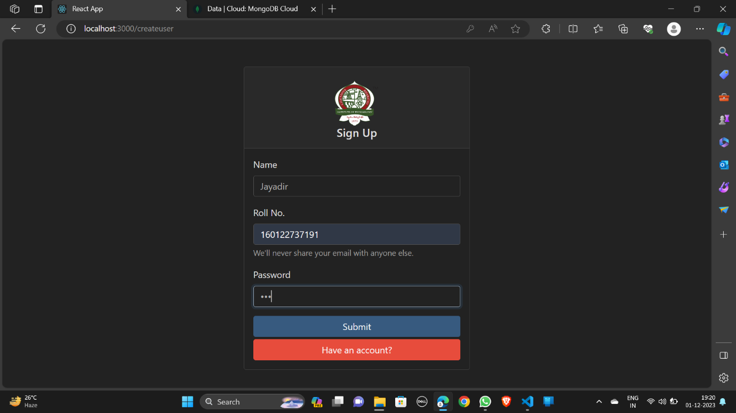

2)LOGIN PAGE:

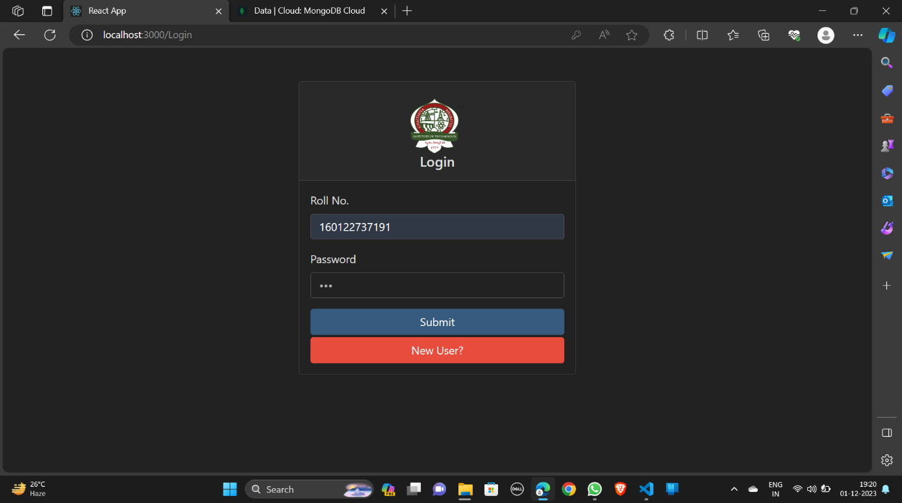

3)HOME PAGE WHEN LOGGED OUT:

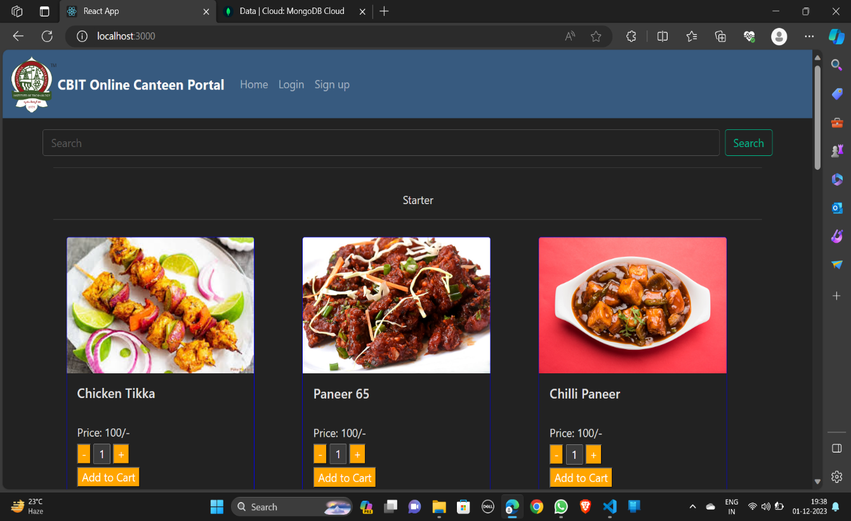

4)HOME PAGE:

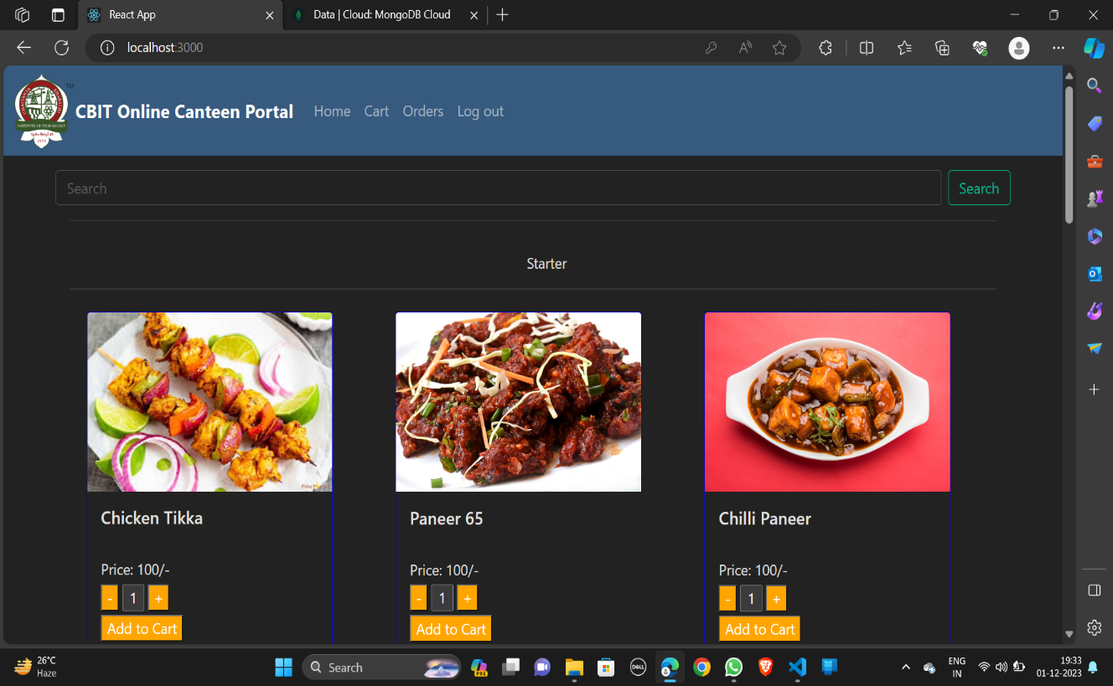

5)CART:

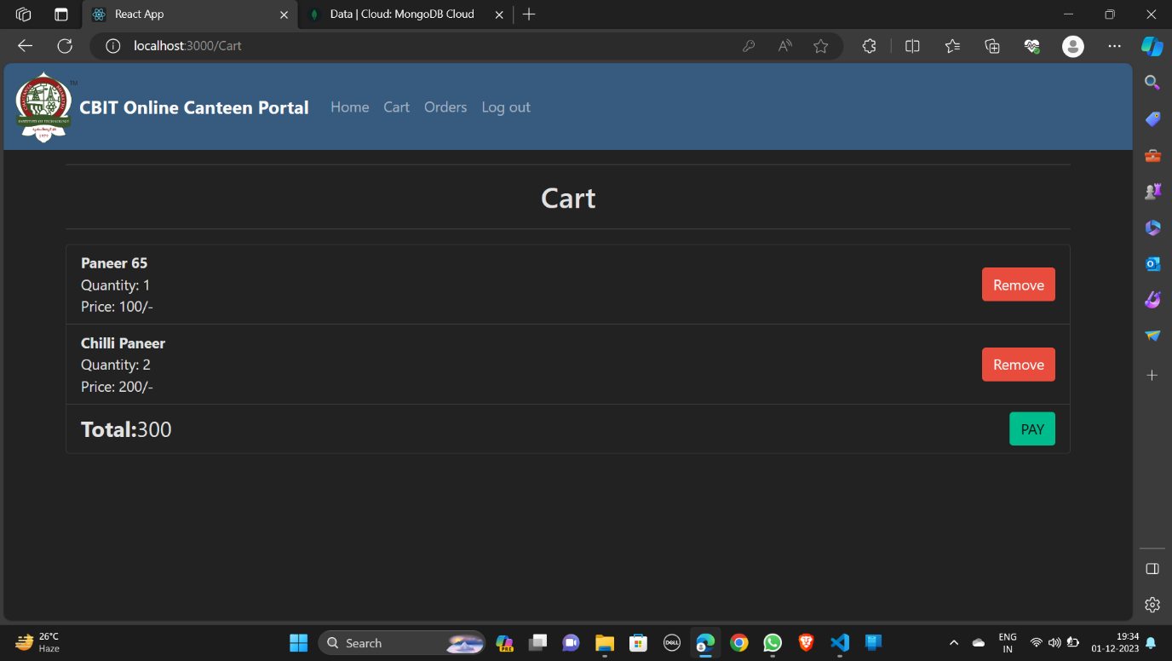

6)CHECKOUT:

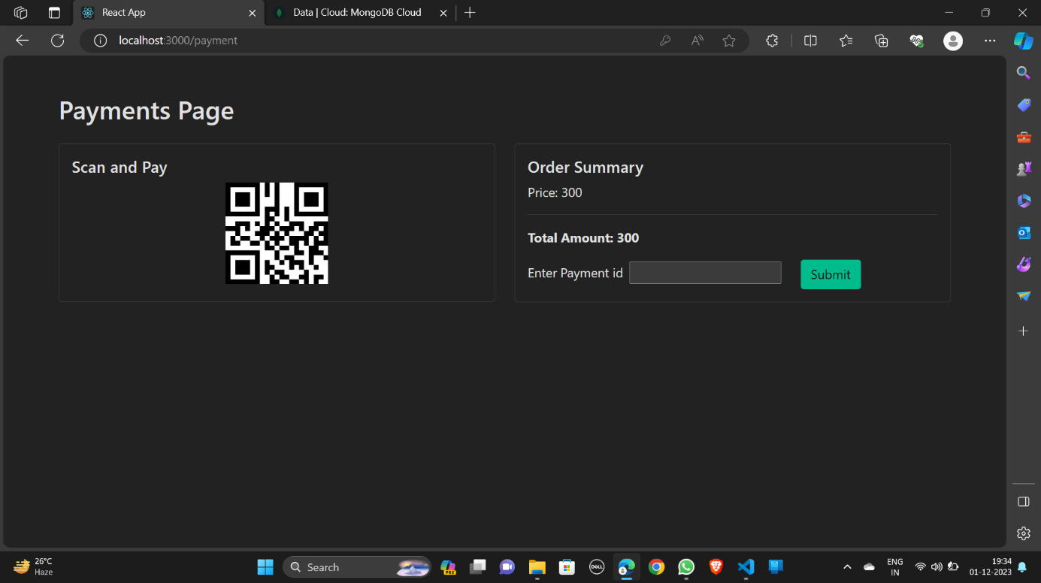

7)NOTIFICATION AFTER PAYMENT:

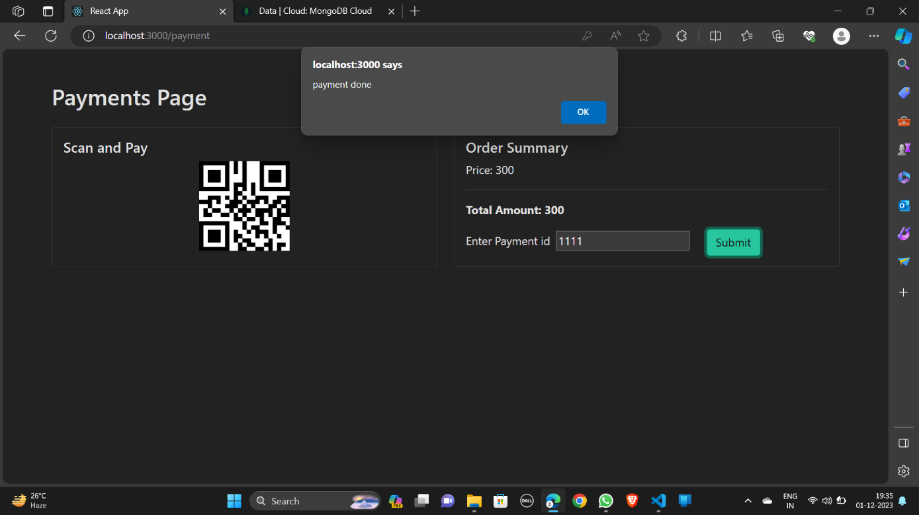

8)EMPTY CHECKOUT:

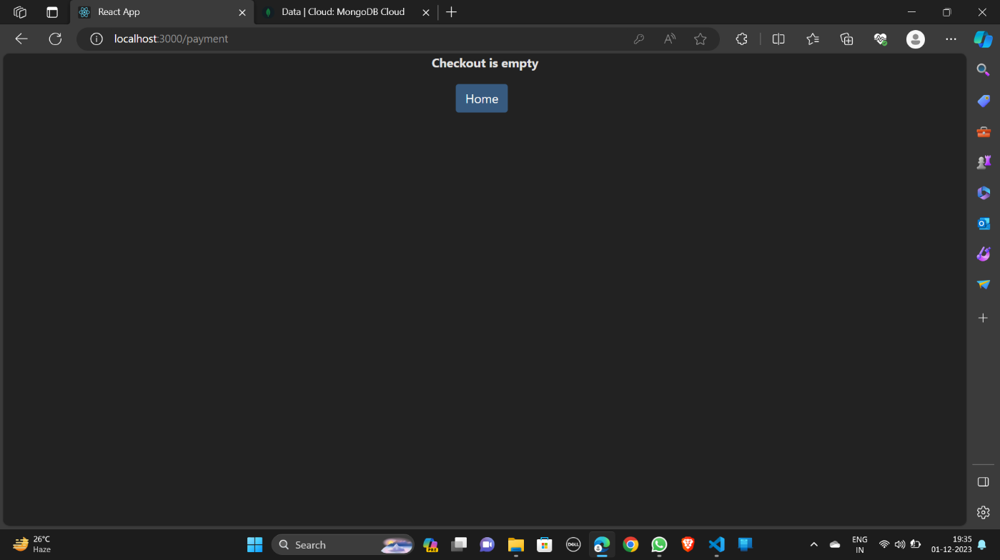

9) PREVIOUS ORDERS:

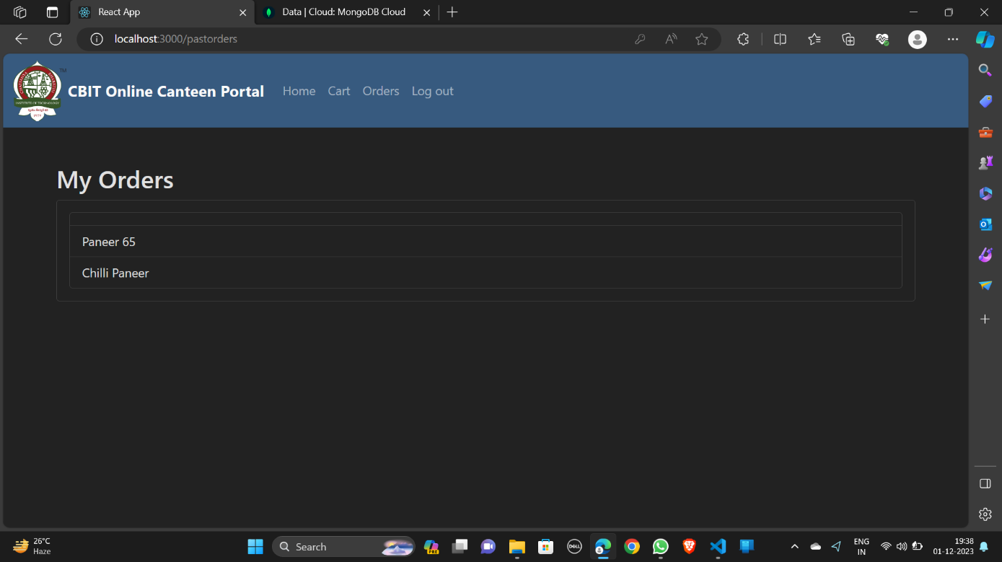

10) DATABASE:

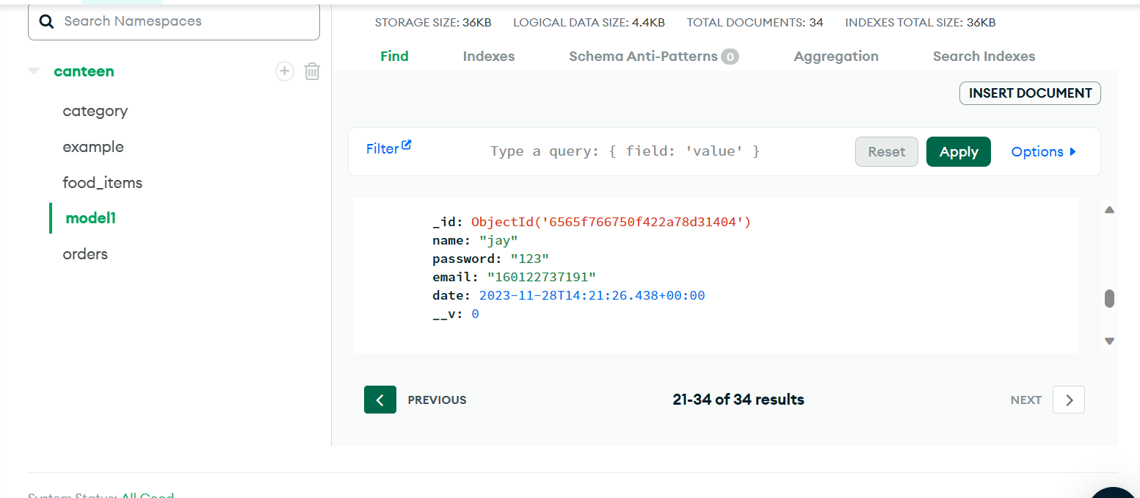

**6. CONCLUSION AND FUTURE SCOPE**

**6.1 CONCLUSION**

In conclusion, the development and implementation of the Online Canteen Portal present a significant leap forward in enhancing the dining experience for students. The integration of modern technologies such as React, Express, Node.js, and MongoDB has resulted in a user-friendly, secure, and scalable platform. By addressing the challenges associated with traditional canteen systems, this project contributes to streamlining food ordering processes and promoting a more efficient, contactless approach.

**6.2 LIMITATIONS**

Despite the success of the Online Canteen Portal, certain limitations should be acknowledged. Connectivity issues may pose challenges, affecting users' ability to place orders in real-time. Additionally, the portal's performance may be influenced by the server load during peak hours. While security measures are in place, continuous monitoring and updates are essential to mitigate potential vulnerabilities.

**6.3 FUTURE SCOPE**

The Online Canteen Portal lays the foundation for future enhancements and expansions. Integration with emerging technologies such as machine learning can be explored to predict user preferences and streamline menu recommendations. Further, collaboration with mobile payment services could enhance the platform's convenience. Continuous user feedback will be invaluable for refining the user interface and introducing new features, ensuring the portal remains at the forefront of meeting user expectations.

**BIBLIOGRAPHY**

MongoDB Documentation: [https://docs.mongodb.com/](https://docs.mongodb.com/%5d(https://docs.mongodb.com/)

Express.js Documentation: <https://expressjs.com/>

React Documentation: <https://reactjs.org/docs/getting-started.html>

Node.js Documentation: <https://nodejs.org/en/docs/>

React Router Documentation: <https://reactrouter.com/>